Chapter 9, Solution 71.

We apply a wye-to-delta transformation.
c

b
a

Z_{ac}

Z_{ab}

Z_{bc}

1 
-j2 
Z_{eq}
j4 

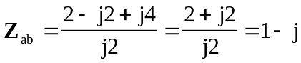
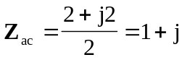
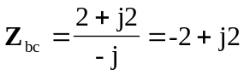

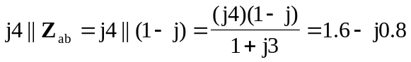
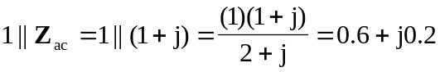
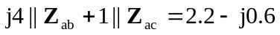

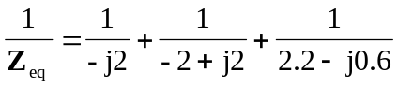

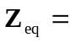 2.473-64.66  = (1.058 – j2.235) 

